



A Course Project Work Report on
“College Event Management & Participation System” Submitted in partial fulfillment of the requirements of CCA Phase-2 for BUILDING ENTERPRISE APPLICATIONS (BCS703B)
in

INFORMATION SCIENCE AND ENGINEERING

By

Anne Thyagaraj USN:1BY23IS031
B Adithi USN:1BY23IS053
Ajay Krishna USN:1BY23IS054
Dhiti Gudihal USN:1BY23IS063

Under the guidance of

Dr. Malini M
Associate Professor

2026-2027

ABSTRACT

The College Event Management and Participation System is a web-based enterprise application developed to simplify and centralize college event management and student participation. Building upon the requirements analysis and architectural design completed during Phase-1, Phase-2 focuses on implementing the application's core modules using a layered monolithic architecture. The system uses React.js and Bootstrap for the frontend, Spring Boot for backend development, REST APIs for communication, and MySQL for data persistence. Spring Data JPA and Hibernate handle database operations, while Spring Security and JSON Web Token (JWT)-based authentication provide authentication and role-based access control. The application supports three roles: Student, Event Coordinator, and Administrator. Students can register for accounts, browse events, manage registrations, view attendance history, and access participation certificates. Coordinators can manage events, participants, attendance, and certificates, while administrators can monitor users, events, registrations, and dashboard statistics. The repository is organized into separate backend, frontend, and database directories and is maintained using Git and GitHub. Static code analysis is included in the quality assurance process to identify potential bugs, vulnerabilities, and code quality issues, with the objective of achieving zero critical bugs. Additional verification includes unit testing, API testing, input validation, and role-based access testing. Initial functional verification confirmed successful student registration and appropriate authorization responses for administrator dashboard access. Further testing and static analysis results will be documented using actual tool outputs. The application has been implemented and executed locally, demonstrating the integration of its frontend, backend, and database components. The project establishes a foundation for subsequent integration testing, deployment, and documentation.

REPOSITORY SETUP & CODE STRUCTURE

Repository Details:
- Project Name: College Event Management and Participation System
- Repository Name: college-event-management
- Repository Link: https://github.com/adeeeteee/college-event-management
- Repository Visibility: Public
- Version Control System: Git
- Repository Hosting Platform: GitHub Branching Practice:
The project uses Git for version control and GitHub for source code hosting. The main branch serves as the primary branch containing the implemented project. The current implementation has been committed and successfully pushed to the remote repository.
The initial commit is recorded with the message "Phase 7 complete - admin module and FR implementation". Future modifications, including integration testing, deployment, and documentation, can be added through subsequent commits to maintain the project's development history.

Project Directory Structure
The project repository is organized into separate frontend, backend, and database directories to maintain a clear separation of responsibilities.
The directory structure is shown below: college-event-management/
│
├── backend/
│ ├── .mvn/
│ │ └── wrapper/
│ ├── src/
│ │ ├── main/
│ │ │ └── java/
│ │ │ ├── com/collegeevent/
│ │ │ │ ├── config/

│ │ │ │ ├── controller/
│ │ │ │ ├── dto/
│ │ │ │ ├── repository/
│ │ │ │ └── service/
│ │ │ └── entity/
│ │ └── test/
│ │ └── java/
│ │ └── com/collegeevent/
│ ├── pom.xml
│ ├── mvnw
│ └── mvnw.cmd
│
├── frontend/
│ ├── public/
│ ├── src/
│ │ ├── assets/
│ │ ├── components/
│ │ ├── pages/
│ │ ├── utils/
│ │ ├── App.jsx
│ │ ├── App.css
│ │ └── index.css
│ ├── package.json
│ ├── package-lock.json
│ └── vite.config.js
│
├── database/
│ └── .gitkeep
│
└── .gitignore

Description of the Directory Structure

Backend Directory
The backend directory contains the server-side implementation developed using Spring Boot and Java. It handles business logic, API requests, authentication, authorization, and database operations.
Its major components are:
  - Config: Contains application configuration, CORS configuration, JWT authentication, and Spring Security settings.
  - Controller: Handles HTTP requests and exposes REST API endpoints for users, events, registrations, certificates, and administrative operations.
  - DTO: Contains Data Transfer Objects used to transfer structured data between the backend and its clients.
  - Repository: Provides database access through Spring Data JPA.
  - Service: Implements the application's business logic, including event management, attendance, registration, authentication, certificates, and administrative functions.
  - Entity: Contains Java entity classes representing users, events, registrations, attendance records, and certificates.
  - Test: Contains the backend test source files.
  - pom.xml: Defines backend dependencies and Maven build configuration.

Frontend Directory
The frontend directory contains the user interface developed using React.js, Bootstrap, and CSS. Its major components are:
  - Public: Contains public assets used by the frontend.
  - Components: Contains reusable interface components, including certificate preview functionality.
  - Pages: Contains the login, student registration, student dashboard, coordinator dashboard, and administrator dashboard pages.
  - Utils: Contains utility functions, including certificate PDF generation.
  - App.jsx: Defines the main application structure and routes.
  - App.css and index.css: Contain application styling.
  - package.json: Defines frontend dependencies and development scripts.
  - vite.config.js: Contains Vite development-server configuration.

Database Directory
The database directory is reserved for database-related resources, such as SQL scripts, schema definitions, and database setup documentation. At present, it contains a .gitkeep file so that GitHub preserves the otherwise empty directory.

Root .gitignore File
The root .gitignore file specifies files and directories that should not be committed to version control. It excludes generated build files, frontend dependencies, local configuration files, IDE files, and logs.

Technology Environment
The following technologies are used to develop the College Event Management and Participation System.

Component | Technology
Frontend | React.js
UI Styling | Bootstrap and CSS
Frontend Development Server | Vite
Backend Framework | Spring Boot
Programming Languages | Java and JavaScript
API Communication | REST APIs
Database | MySQL
ORM Framework | Hibernate
Data Persistence | Spring Data JPA
Authentication | JSON Web Token (JWT)
Authorization | Spring Security and Role-Based Access Control
Backend Build Tool | Maven
Frontend Package Manager | npm
Version Control | Git
Source Code Hosting | GitHub
API Testing | Postman

Execution and Setup Commands
The application consists of two main components: the Spring Boot backend and the React frontend. Both components run separately during local development and communicate through REST APIs.

Backend Execution
The backend can be started using the Maven Wrapper provided in the project.

Commands:
cd E:\College-Event-Management\backend
.\mvnw.cmd spring-boot:run
The backend starts on port 8080 when the application and database are configured correctly.
Backend URL: http://localhost:8080

Frontend Execution
The frontend is started using the Vite development server.

Commands:
cd E:\College-Event-Management\frontend npm run dev
The frontend development server typically starts on port 5173.
Frontend URL: http://localhost:5173

Database Configuration
MySQL must be running before the backend starts successfully. The database connection details are configured in the local application.properties file.
The local configuration file is excluded from GitHub to prevent database credentials from being committed to the repository.

Application Execution Sequence
The following steps are used to run the complete application:
  - Start the MySQL database service.
  - Open a terminal and start the Spring Boot backend.

  - Open a second terminal and start the React frontend.
  - Open the frontend URL in a web browser.
  - Log in and access the application according to the assigned user role.
This setup enables the frontend, backend, and database to work together as a complete web-based enterprise application.

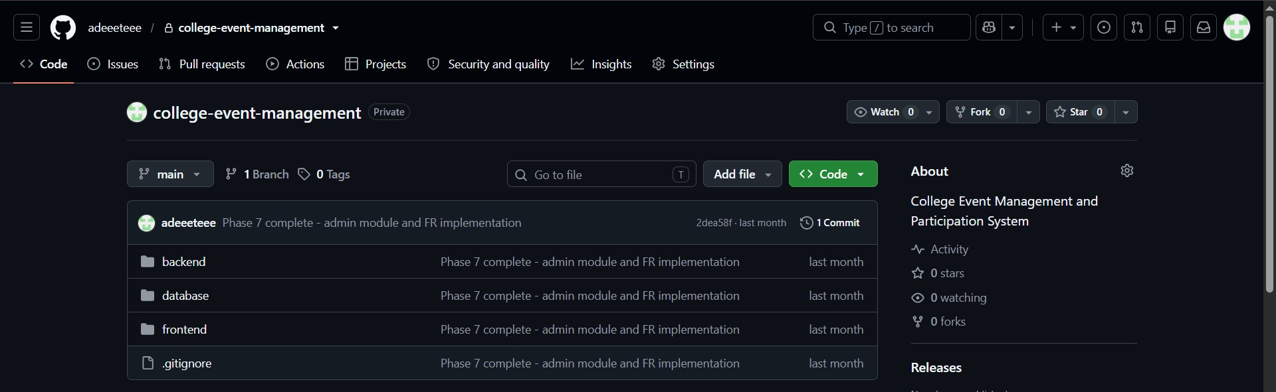
Figure 1: GitHub repository structure of the College Event Management and Participation System.

STATIC CODE ANALYSIS

Tool Used
Static code analysis is an important software quality assurance activity used to identify potential coding errors, maintainability issues, and deviations from coding standards without executing the application. For the College Event Management and Participation System, ESLint is used to examine the frontend JavaScript and React code. Maven and the Java compiler are used to verify backend compilation and identify compilation-related issues.
The tools used are:

- ESLint: Examines JavaScript and React source files for code-quality issues and violations of configured coding rules.
- Maven: Manages backend dependencies and supports compilation and build verification.

- Java Compiler: Detects syntax errors and type-related compilation errors in Java source files.

These tools help improve source-code quality and identify issues before the application is executed.

Quality Metrics Summary
The following metrics are recorded after executing the relevant checks.

Quality Metric | Result
Frontend Analysis Tool | ESLint
Backend Build Tool | Maven
Critical Bugs | verified
Security Vulnerabilities | verified
Code Warnings / Issues | No Issues
Compilation Status | Successful
Analysis Status | Successful

The analysis results will be used to identify code-quality issues and determine whether corrective changes are necessary. The project aims to maintain clean, readable, and reliable code with no critical issues.

Code Issues Identified and Resolved
The source code is examined to identify potential issues, including unused imports, unused variables, inconsistent coding practices, and violations of configured linting rules.
The following Checks done are as follows:

Issue Detected | File Name | Fix / Refactoring Applied
No lint issues reported during the  executed analysis | Frontend source  files | No corrections required for the issues  checked by ESLint
No compilation errors detected | Backend Java  source files | No compilation-related corrections required  during this build

Verification Proofs
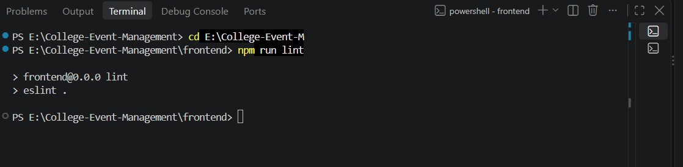
Figure 2: ESLint output showing frontend code-quality analysis results.

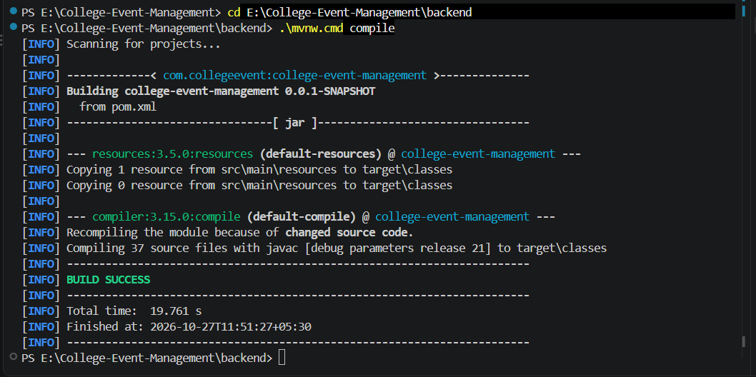
Figure 3: Maven build output showing backend compilation status.
These results provide evidence of the checks performed on the application. Additional security analysis may be required to establish the presence or absence of security vulnerabilities.

TESTING EXECUTION

Test Framework Used
The backend testing process uses JUnit with Spring Boot's testing support to verify application initialization and backend configuration. Maven is used to execute the automated test suite. The frontend and REST API functionality can additionally be verified through ESLint checks, browser-based functional testing, and Postman API requests.

Automated Test Execution Results

Metric | Actual Result
Test framework | JUnit / Spring Boot Test
Total tests executed | 1
Passed | 1
Failed | 0
Errors | 0
Skipped | 0
Build status | BUILD SUCCESS

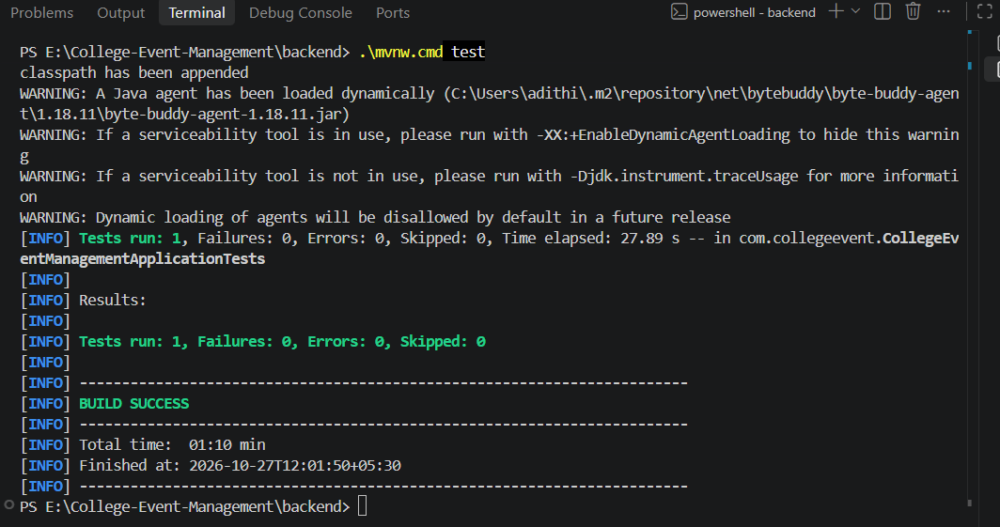
Figure 4: Successful execution of the Spring Boot automated test using Maven

Test Case Table

Test ID | Test Level (Unit /  API) | Function / Endpoint Tested | Input / Action | Expected Result | Status (Pass/ Fail)
TC-01 | Unit | Backend Application Initialization | Run the automated test using Maven | Application context loads successfully; test completes without failures | Pass
TC-02 | API | POST /api/users | Submit valid student details | HTTP 200 OK with the created user's details | Pass
TC-03 | API | /api/admin/dashboard | Send a request using a valid Admin token | HTTP 200 OK;  access is granted | Pass
TC-04 | API | /api/admin/dashboard | Send an Admin Dashboard request using a Student token | HTTP 403  Forbidden; access is denied | Pass
TC-05 | API | /api/admin/dashboard | Send an Admin Dashboard request using a Coordinator token | HTTP 403  Forbidden; access is denied | Pass
TC-06 | Unit | User Password Encryption | Encode a sample Password  using BCrypt | Password is encrypted successfully and does not match the original  plain-text password | pass
TC-07 | Unit | JWT Token Generation | Generate a token for a valid username | JWT token is Generated successfully | Pass
TC-08 | Unit | Event Entity Creation | Create an event object with sample event details | Event object is created with the correct details | Pass

TC-09 | Unit | Registration Entity Creation | Create a registration object with valid student and event details | Registration object is Initialized successfully | Pass
TC-10 | Unit | Attendance Status Update | Set attendance status to PRESENT | Attendance status is updated successfully | Pass
TC-11 | Unit | Certificate Entity Creation | Create a certificate object with sample student and event details | Certificate object is created successfully | Pass

Execution Proofs
Figure 5: Successful execution of the automated backend test using Maven.

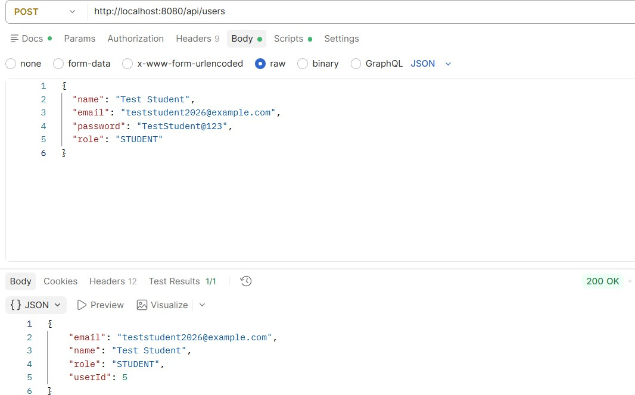
Figure 6: Successful execution of the user creation API using Postman.

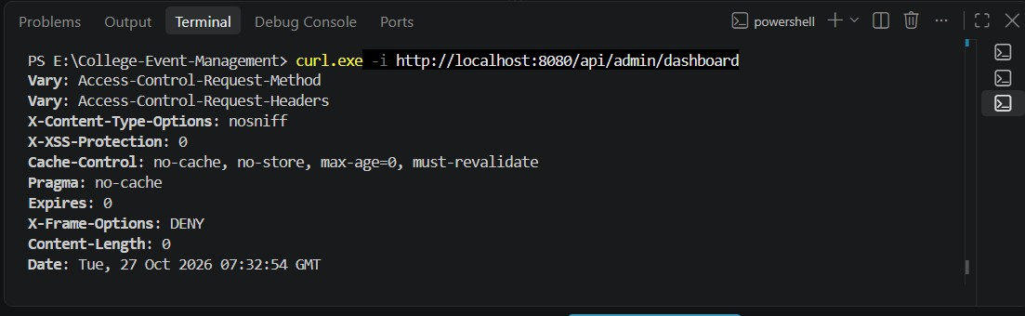
Figure 7: Verification of administrator access to the dashboard API using a valid authentication token, returning HTTP 200 OK.

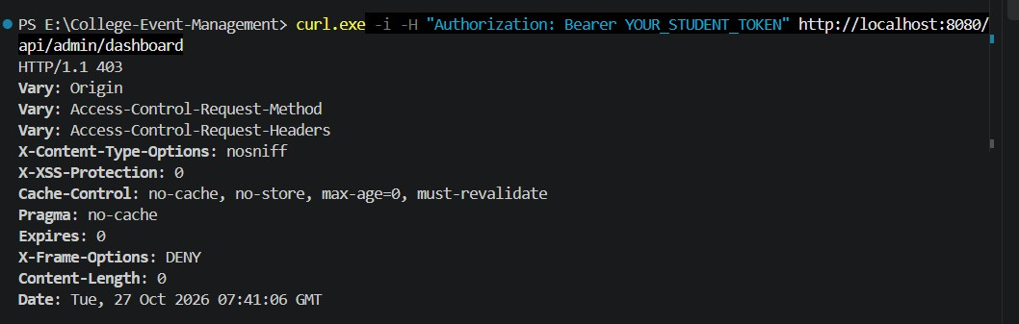
Figure 8: Verification of administrator access to the dashboard API using a valid authentication token, returning HTTP 200 OK.

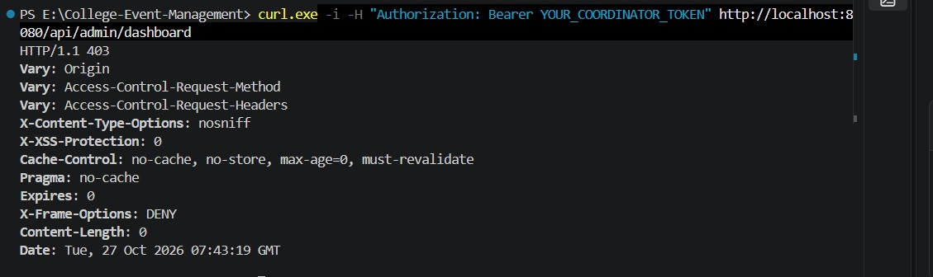
Figure 9: Verification of role-based access control by denying coordinator access to the administrator dashboard API, returning HTTP 403 Forbidden.
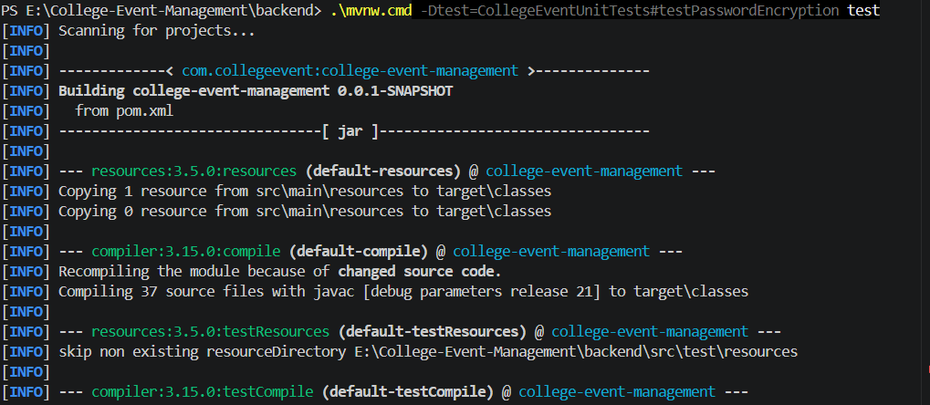
Figure 10: Successful execution of the unit test verifying BCrypt password encryption.

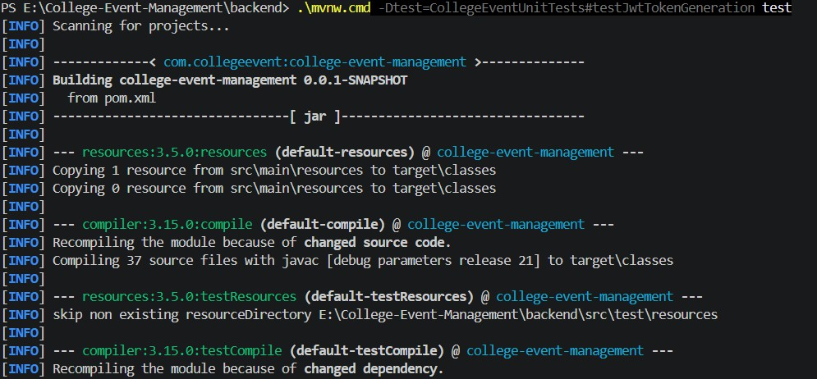
Figure 11: Successful execution of the unit test verifying JWT token generation for a valid user.

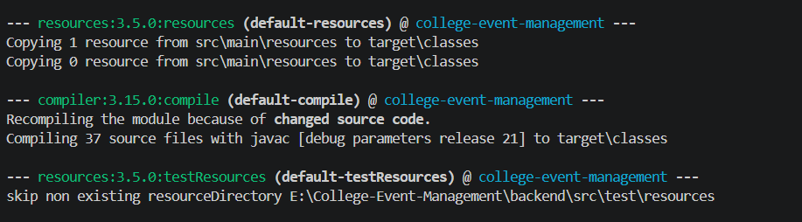
Figure 12: Successful execution of the unit test verifying event entity creation with valid details.

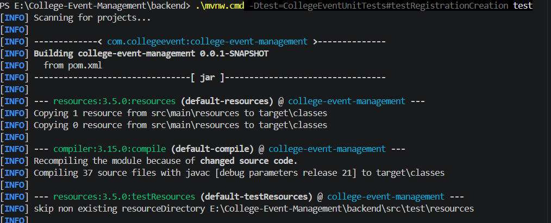
Figure 13: Successful execution of the unit test verifying registration entity initialization.

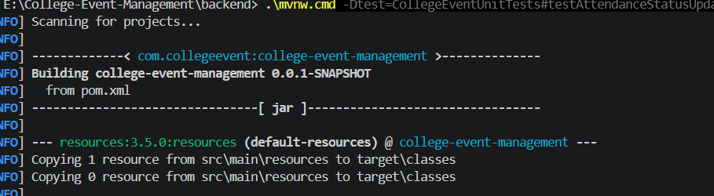
Figure 14: Successful execution of the unit test verifying attendance status update.

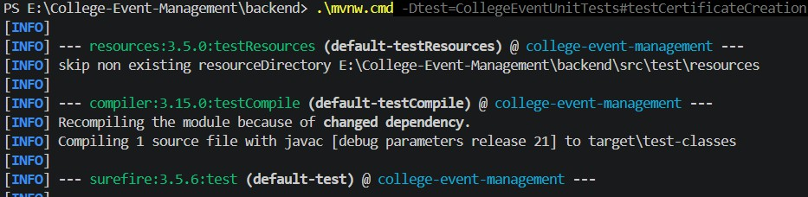
Figure 15: Successful execution of the unit test verifying certificate entity creation.

CORE IMPLEMENTATION

Module 1: User Interface / Presentation
The user interface was developed using React.js, with Bootstrap and CSS for styling. The application provides separate interfaces for Students, Coordinators, and Administrators. Students can browse events, register for events, and view their certificates. Coordinators can manage events, view participants, and mark attendance. Administrators can access the dashboard to monitor users, events, and registrations.
The interface is designed to provide simple navigation and role-based access to the available features.

Figure 16: User Interface of the College Event Management & Participation System

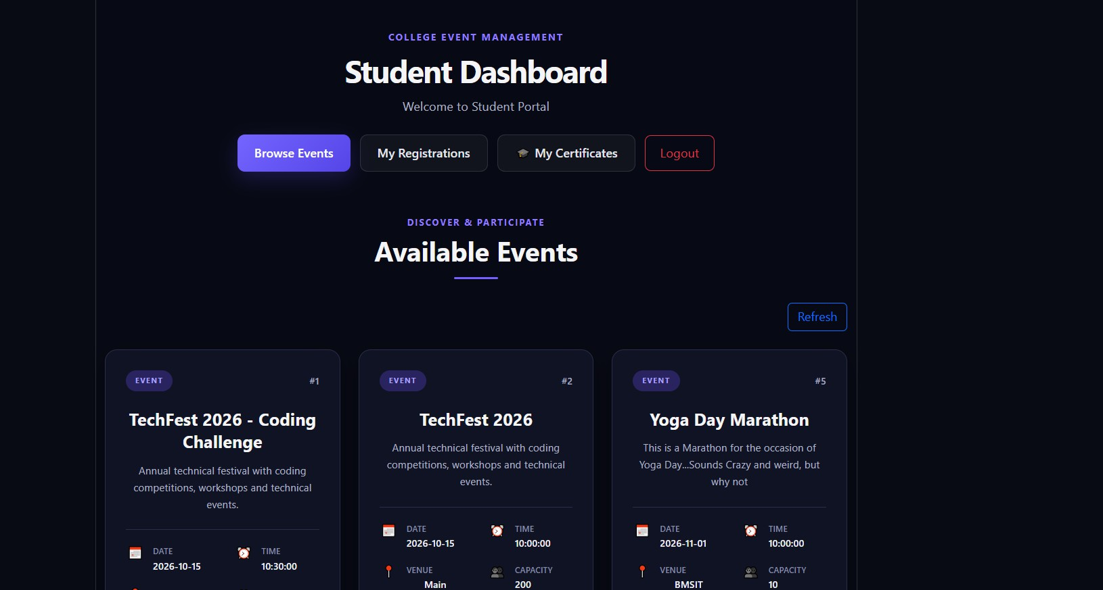
Figure 17: Student interface displaying available college events.

Module 2: Core Business Logic / Processing
The backend business logic was implemented using Java and Spring Boot. REST APIs handle user authentication, event management, event registration and cancellation, participant management, attendance tracking, and certificate generation. Spring Security and JSON Web Tokens (JWT) are used for authentication and role-based access control. The system verifies user permissions before allowing access to restricted administrative functions. Registration and attendance operations are processed through backend service classes to maintain consistent application behavior.

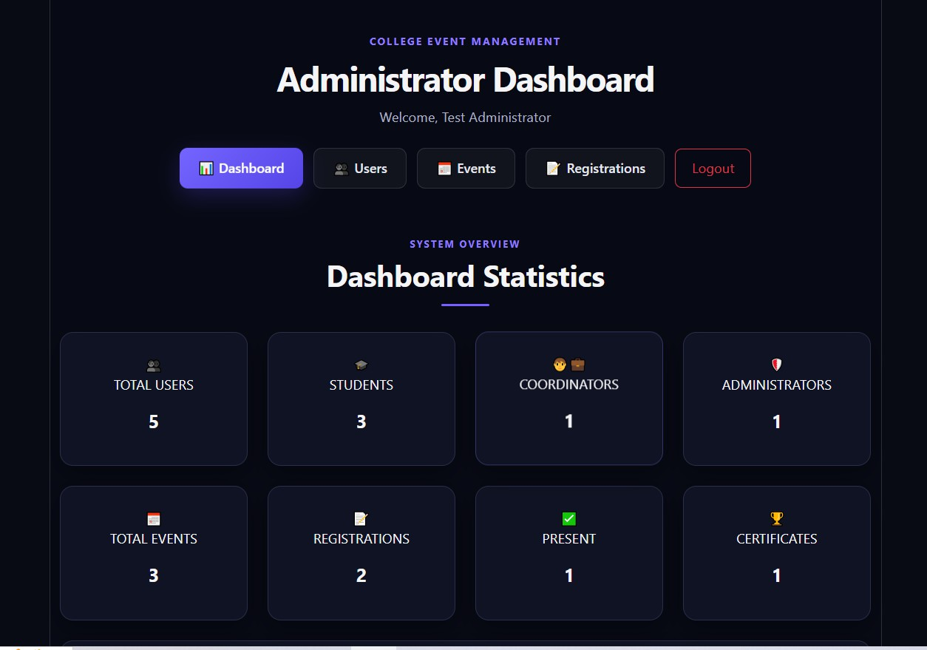
Figure 18: Administrator dashboard for monitoring users, events, and registrations.

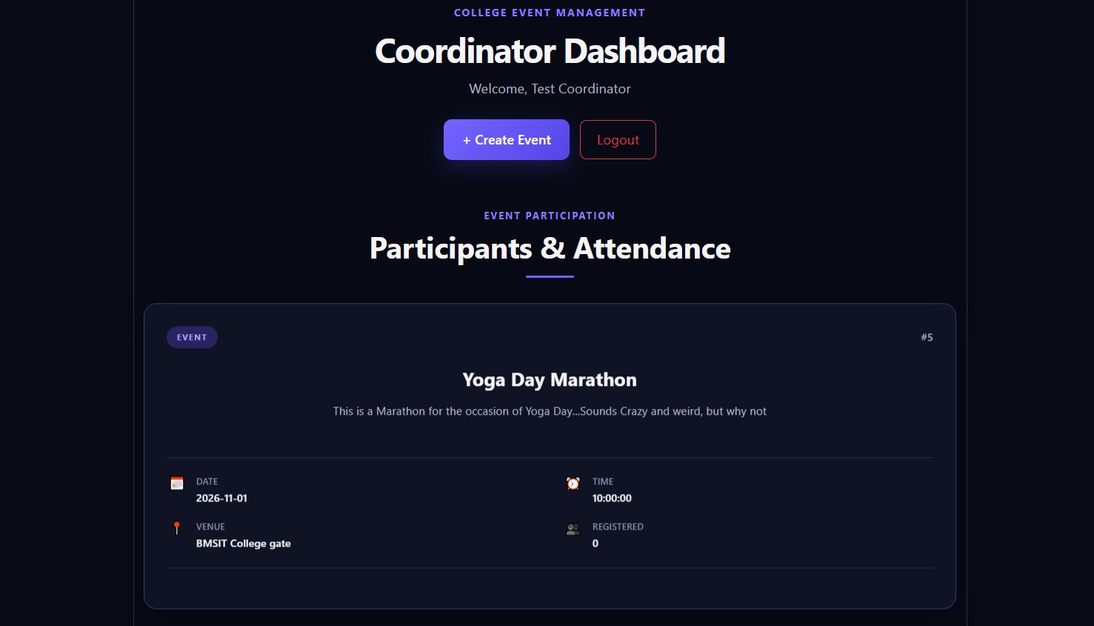
Figure 19: Event Participation and management functionality.

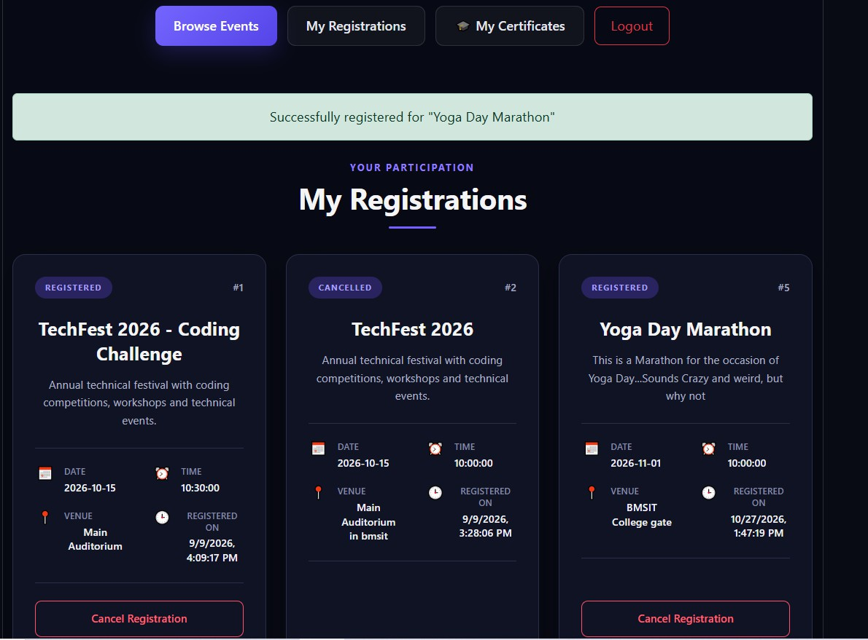
Figure 20: Event Registrations done by the Student

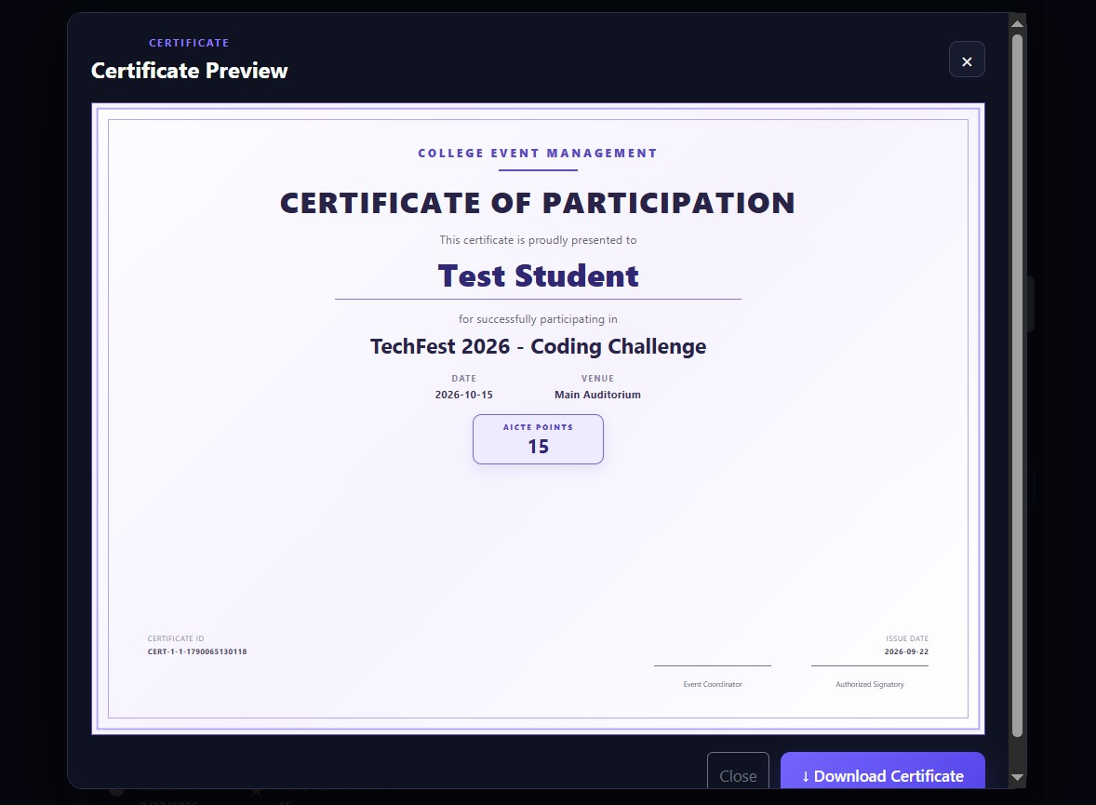
Figure 21: Certificate Preview and download

Module 3: Data Persistence and Integration
MySQL is used as the relational database for storing user accounts, event information, registrations, attendance records, and certificate-related data. Spring Data JPA and Hibernate manage database interactions through entity classes and repository interfaces. The React frontend communicates with the Spring Boot backend through REST APIs to submit requests and retrieve information. This integration allows application data to be stored, updated, and retrieved from the database as users perform different operations.

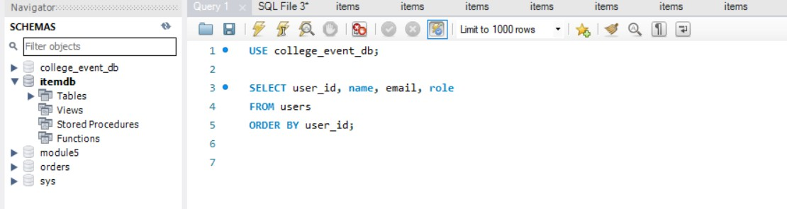
Figure 22: Data Base queries

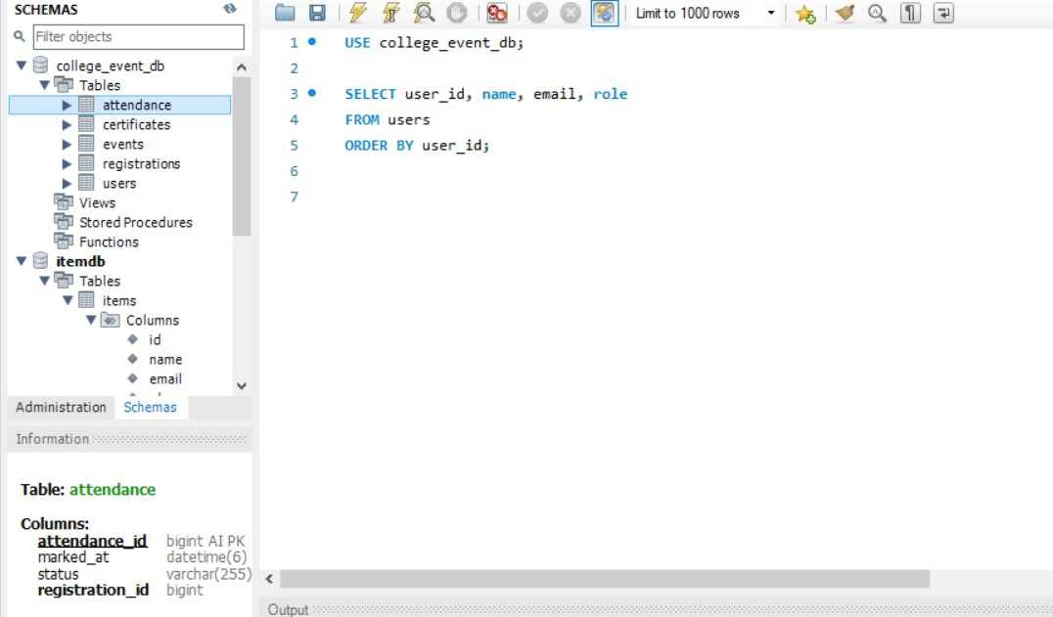
Figure 23: Tables Expansion in the Database

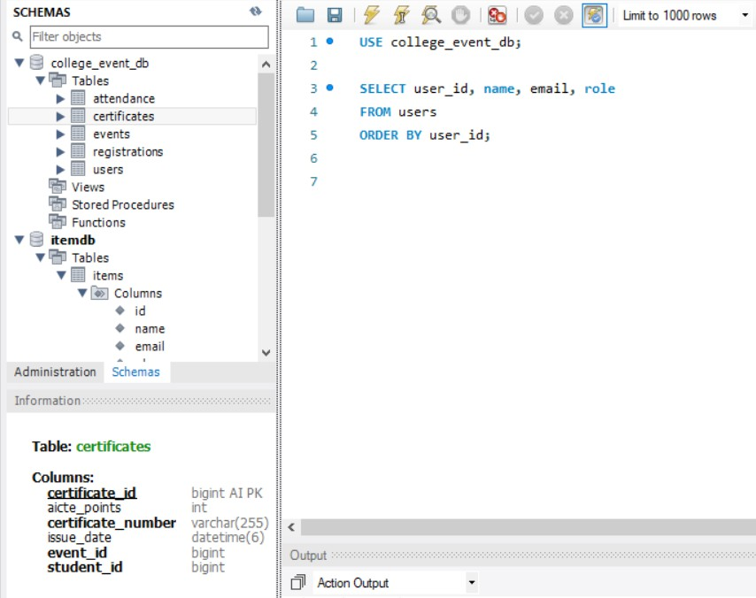
Figure 24: Function expansion of certificates

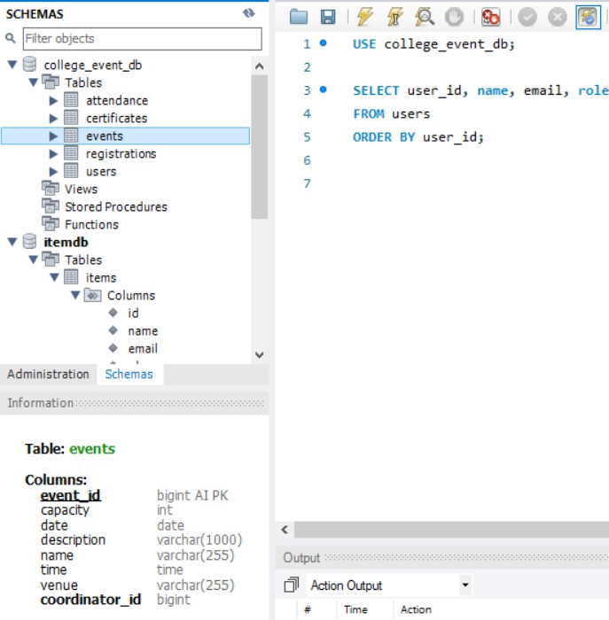
Figure 25: Function Expansion of Events.

EVALUATION RUBRICS

Construction Readiness, Testing and Implementation
(60 MARKS Scaled Down to 10 marks)
S.No | Evaluation  Criteria | Excellent | Good | Needs  Improvement | Max  Marks | Marks  Obtained
1. | Repo Setup & Code Structure | Well-organized GitHub/GitLab repo setup with modular folder organization.  (9-10 marks) | Fairly organized  repository with minor  structural flaws. | Disorganized repo; lacks clear modular structure.  (0-5 marks) | 10
 |  |  | (6-8 marks)
2. | Static Code Analysis | Tool executed; zero critical bugs; report submitted. | Tool executed; minor code bugs present.  (9-12 marks) | Static analysis not performed or results ignored. | 15
 |  | (13-15  marks) | Tool executed; minor code bugs present.  (9-12 marks) | (0-8 marks)
3. | Testing Execution | Working Unit and API/Integration tests with  passing logs | Working unit tests, but  limited integration test coverage. | Missing  unit/integration tests or execution  errors. | 20
 |  | (17-20  marks) | (11-16  marks) | (0-10 marks)
4. | Implementation | Functional  implementation of core modules matching  architectural design. (13-15  marks) | Partial  implementation with minor functional bugs or gaps | Incomplete or non-functional module  implementation. | 15
 |  |  | (9-12 marks) | (0-8 marks)
TOTAL MARKS

Signature of Course Co-Ordinator

REFERENCES/BIBLIOGRAPHY

- React Team, “React Documentation.” [Online]. Available: https://react.dev/. [Accessed: Oct. 27,

2026].

- VMware, Inc., “Spring Boot Reference Documentation.” [Online]. Available: https://docs.spring.io/spring-boot/documentation.html. [Accessed: Oct. 27, 2026].
- Oracle, “Java Documentation.” [Online]. Available: https://docs.oracle.com/en/java/. [Accessed:

Oct. 27, 2026].
- Oracle Corporation, “MySQL Reference Manual.” [Online]. Available: https://dev.mysql.com/doc/.
[Accessed: Oct. 27, 2026].

- Spring, “Spring Security Reference.” [Online]. Available: https://docs.spring.io/spring-

security/reference/. [Accessed: Oct. 27, 2026].

- L. Bradley and J. Sakimura, “JSON Web Token (JWT),” RFC 7519, Internet Engineering Task Force (IETF), May 2015. [Online]. Available: https://www.rfc-editor.org/rfc/rfc7519.html.
- Eclipse Foundation, “Eclipse Jakarta Persistence.” [Online]. Available: https://jakarta.ee/specifications/persistence/. [Accessed: Oct. 27, 2026].
- Hibernate Team, “Hibernate ORM Documentation.” [Online]. Available: https://hibernate.org/orm/documentation/. [Accessed: Oct. 27, 2026].
- Bootstrap Team, “Bootstrap Documentation.” [Online]. Available: https://getbootstrap.com/docs/.

[Accessed: Oct. 27, 2026].

- Apache Software Foundation, “Apache Maven Project.” [Online]. Available: https://maven.apache.org/. [Accessed: Oct. 27, 2026].

